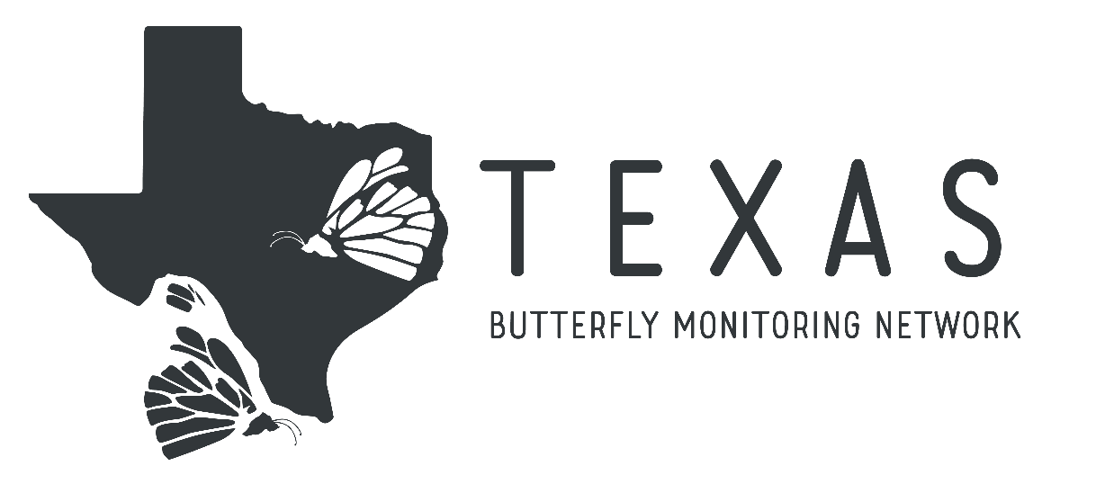
Introduction

The Texas Butterfly Monitoring Network is a citizen science butterfly monitoring program started in cooperation with the North American Butterfly Monitoring Network. With long-term monitoring of Texas butterflies, we will be able to trace movement of populations, changes in abundance, and other important data points that will help with the study of butterflies and the conservation of butterfly habitats. Texas has more butterfly species than any other state in the United States, so it is of particular interest in butterfly conservation, and citizen scientists are key to keeping tabs on the butterflies around the state.
Data will be collected for the project using a modified Pollard Walk protocol. Participants will walk the same route a minimum of nine times between March 1st and November 30th, with at least four walks occurring before July 15th and at least four walks occurring after that date. The participant will record any butterfly seen within a six meter (about 20 feet) radius identified as specifically as is possible with high confidence. This data will be entered into the PollardBase database before the end of the monitoring season so that we can analyze the results and keep a record of all the butterflies seen.

Picking a Route
A route should take the monitor anywhere from 30 minutes to 2 hours to complete. The route should follow existing paths if possible and should be easy for a new monitor to find and repeat if the current monitor leaves the network. The ideal route should include up to five different habitat sites, as determined by the route founder. These sites can be named according to the founder and should be easy to identify. Habitat names such as “pine woods,” “prairie,” “pond edge,” or “maintained park area” work great. Subdivisions such as “wet prairie” or “dry prairie” can also be used. If you want assistance founding a route or would prefer to use a route that has already been founded, contact your county chapter lead or the director of the Texas Butterfly Monitoring Network at butterflymonitorstx@gmail.com.

When to Survey
Surveys should ideally be done on mostly sunny days when it is at least 70 degrees outside. These are optimal conditions for butterflies. Whatever the weather conditions, they must be recorded on the data sheet so that data can be compared without bias. Monitoring should start at 10am or later and should be completed by no later than 4pm in order to catch the butterflies at peak activity level.

Conducting a Survey
Only one person should conduct a survey at a time. You may (and it is recommended that you do) bring along a note taker, but the note taker should not record any butterfly observations. This keeps the data consistent. Do not monitor while doing other activities that might distract from observing butterflies, as this can cause inconsistencies in the data.
You MUST record starting and ending times. This is incredibly important for data analysis so that we can use the metric of butterflies sighted per hour. Routes should be walked at a constant pace unless you are pausing to identify a butterfly. If you take a break for whatever reason, please record the break times as well.

Identifying the Butterflies
Never guess when identifying butterflies. Only identify as far as you are completely confident. Observations such as “unknown sulfur,” “unknown skipper,” and “question mark/comma” are still useful data. Incorrect identifications will result in incorrect data.
If possible and allowed by site regulations, butterflies can be netted for identification. They should be handled very carefully and released as soon as they have been identified. Please do not collect specimens as part of your Pollard Walk, though you can net a butterfly for identification and then release once you know what it is.

For Additional Information go to www.texasbutterflies.org

